**PROJECT REPORT**

**VISUALIZATION TOOL FOR ELECTRIC VEHICLE CHAGEAND RANGE ANALYSIS**

1.Introduction

* 1. Overview

A vehicle that can be powered by an electric motor that draws electricity from a battery and is capable of being charged from an external source and have an electric motor instead of a internal combustion engine.

The electric Vehicle is not new, but it has been receiving significantly more attention in recent years. Advances in both EV analytics and battery technologies have led to increased automotive market share. However, this growth is not attributed to hardware alone. The modern mechatronic vehicle marries electrical storage and propulsion systems with electronic sensors, controls, and actuators, integrated closely with software, secure data transfer, and data analysis, to form a comprehensive transportation solution. Advances in all these areas have contributed to the overall rise of EV’s, but the common thread that runs through all these elements is data analytics..

* 1. Purpose

The purpose of electric vehicle (EV) range and charge analysis is to provide drivers, fleet managers, energy providers, and policymakers with critical information about the range and charging requirements of EVs. By analyzing the range and charge of an EV, stakeholders can:

Plan trips: Drivers can plan their trips based on the range of their EV and the location of charging stations.

Optimize routes: Fleet managers can optimize their routes based on the range and charging requirements of their EVs, reducing downtime and increasing productivity.

Manage battery performance: Drivers can manage the performance of their EV battery by monitoring its charge level and avoiding situations that can degrade the battery, such as overcharging or rapid charging.

Plan for increased demand: Energy providers can use range and charge analysis to plan for the increased demand for electricity due to the growing adoption of EVs and develop new energy storage solutions.Bottom of Form

2 Problem definition and design thinking.

2.1 Empathy map

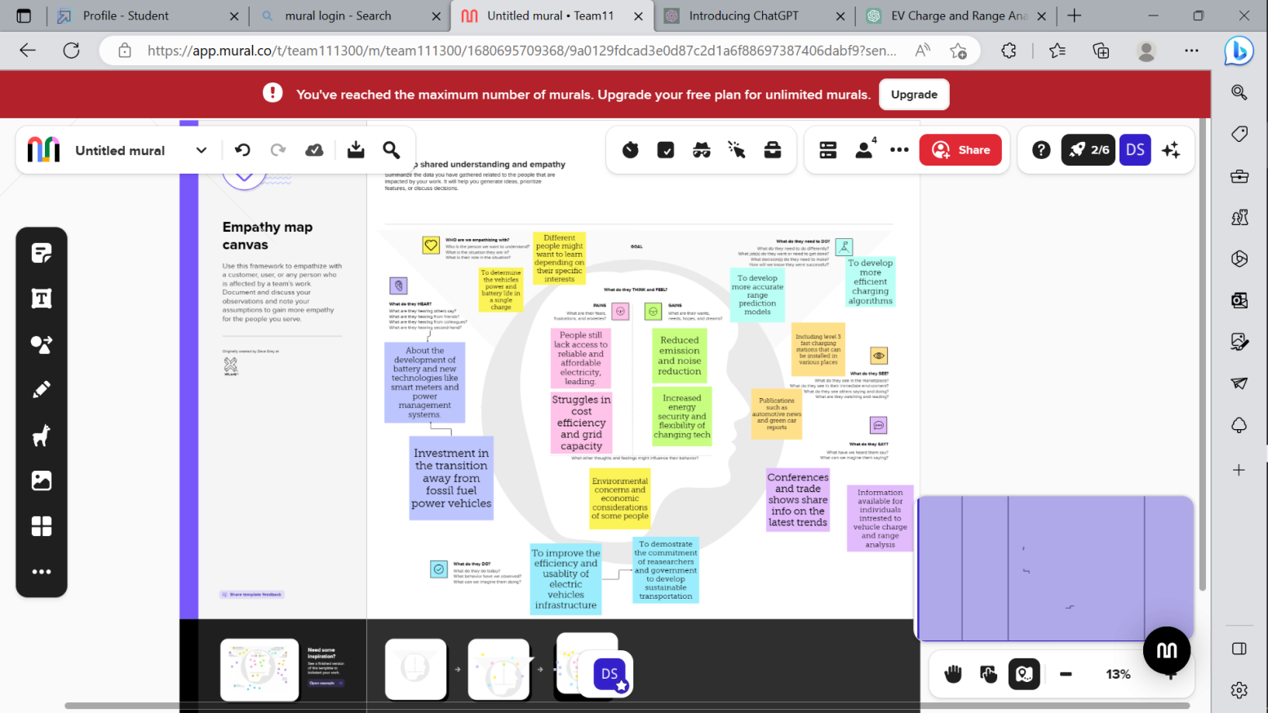

2.2 Ideation and Brainstorming Map

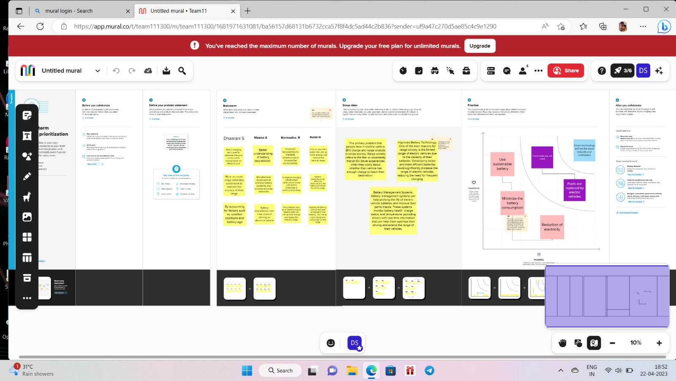

3 Result

Activity & Screenshot

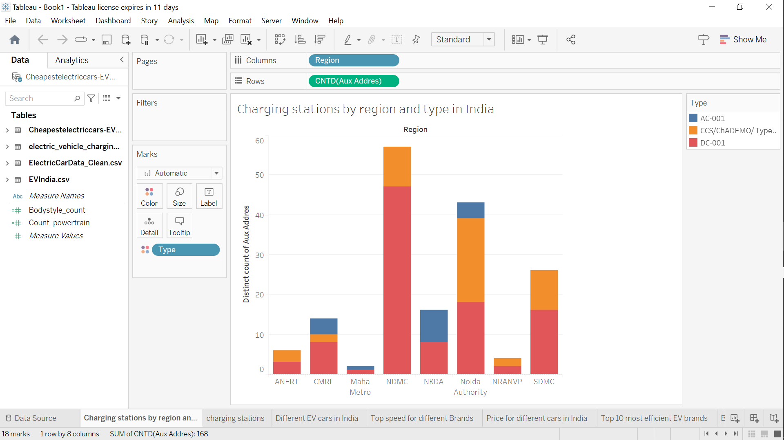

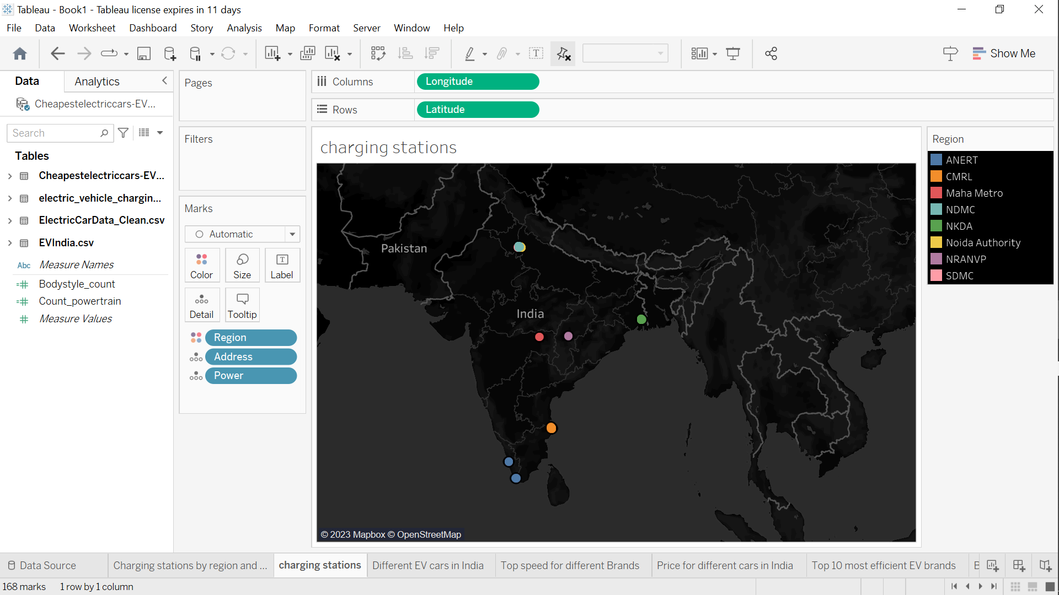

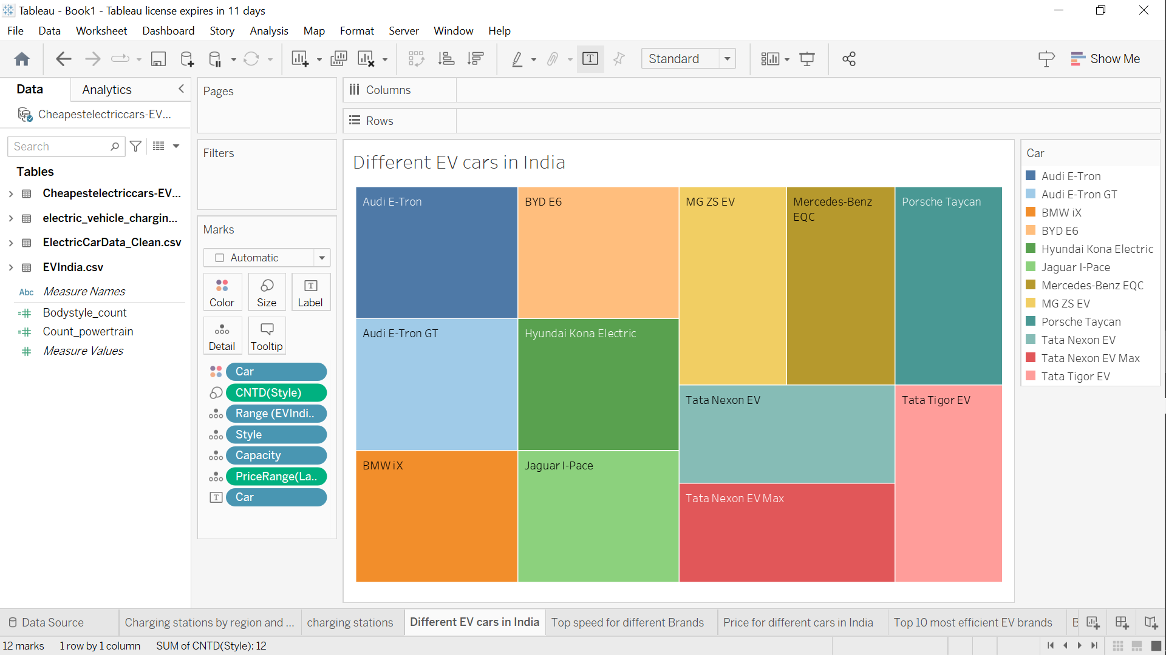

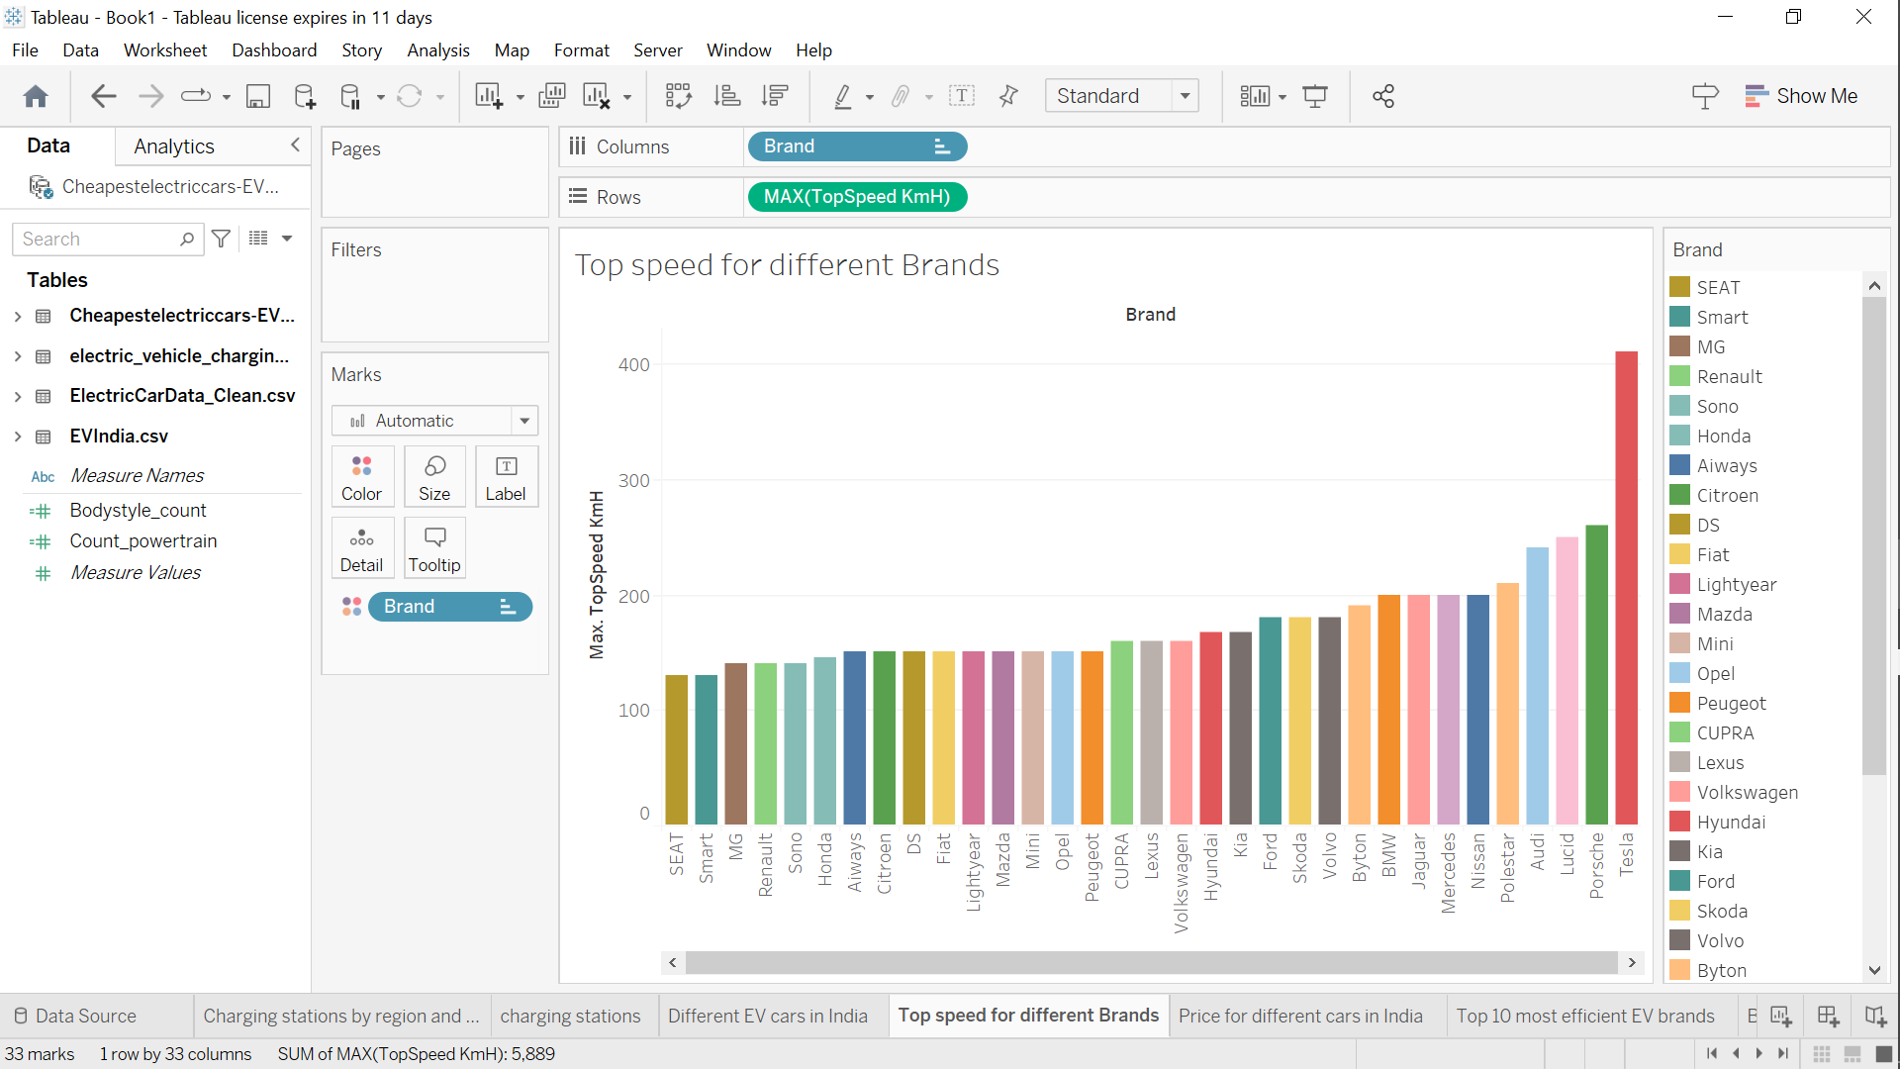

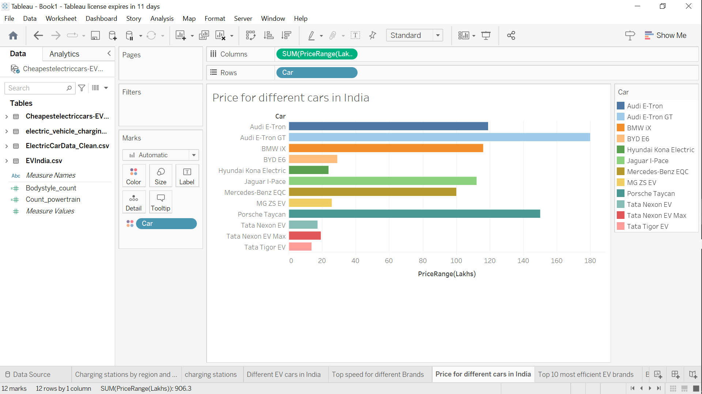

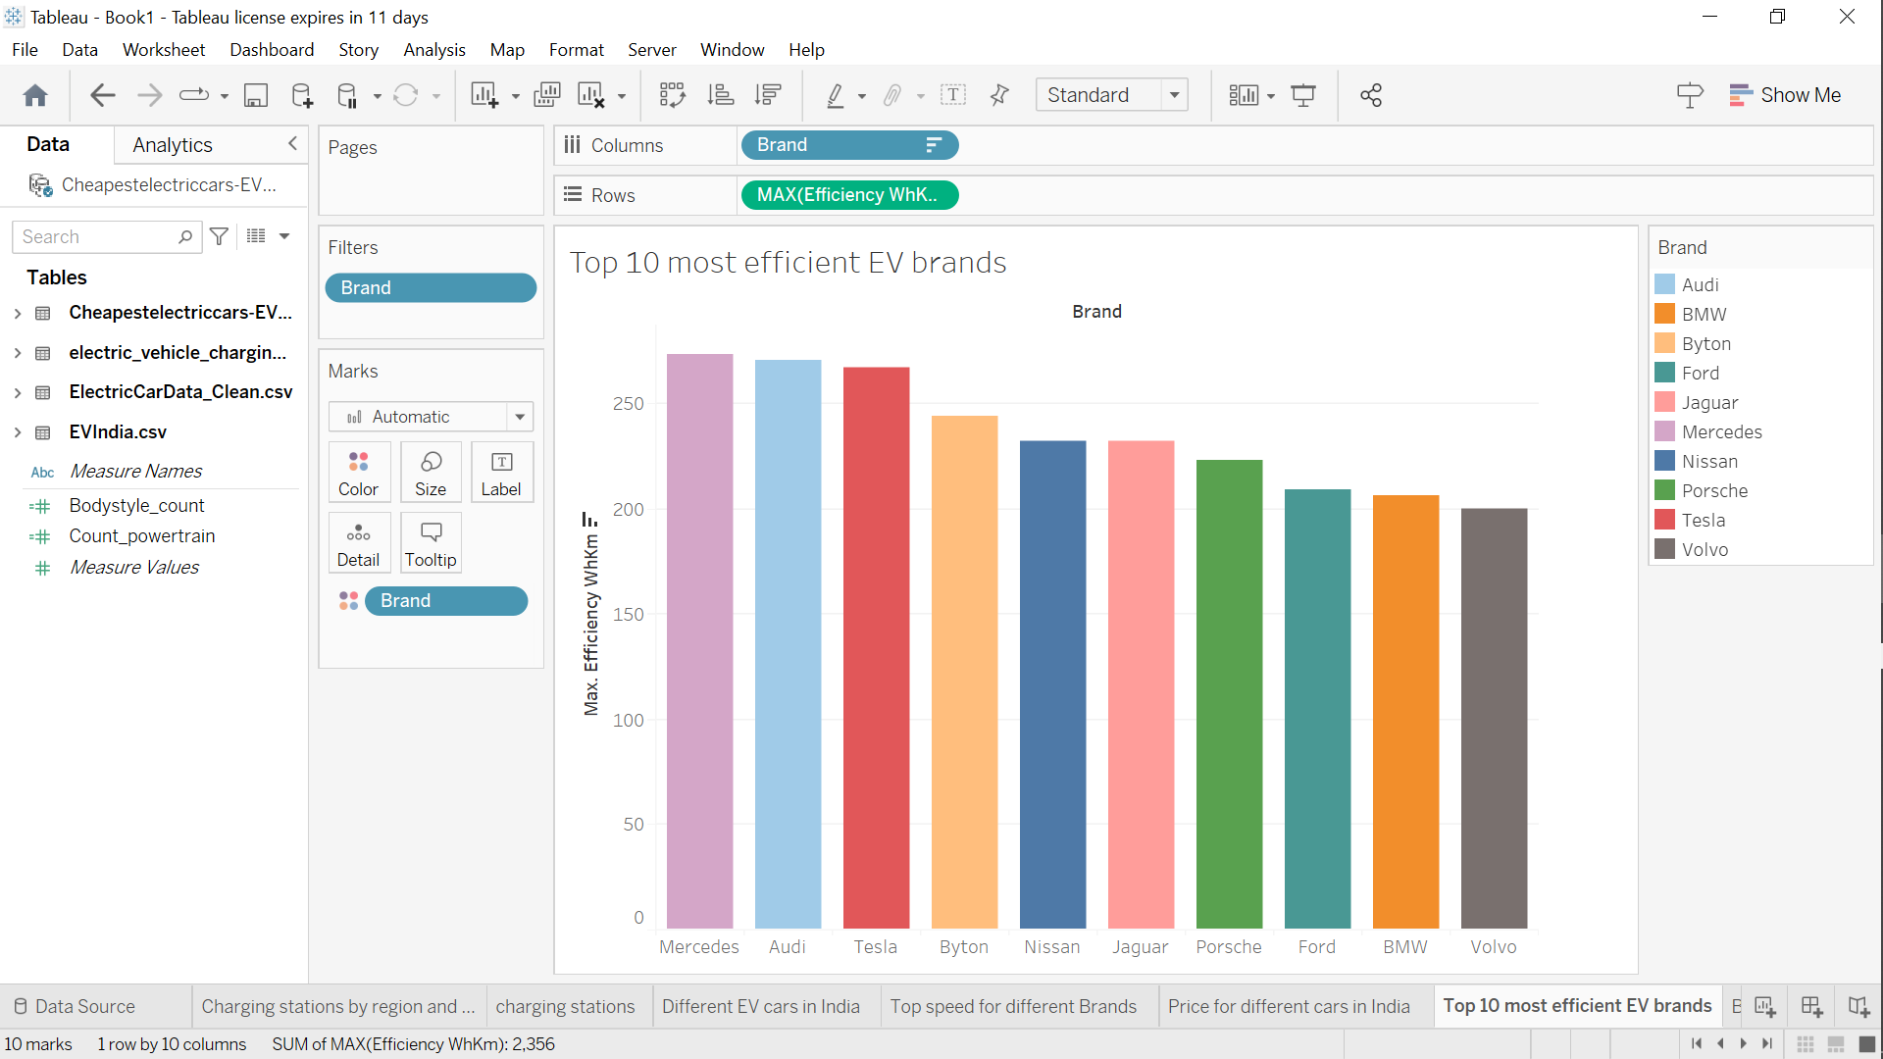





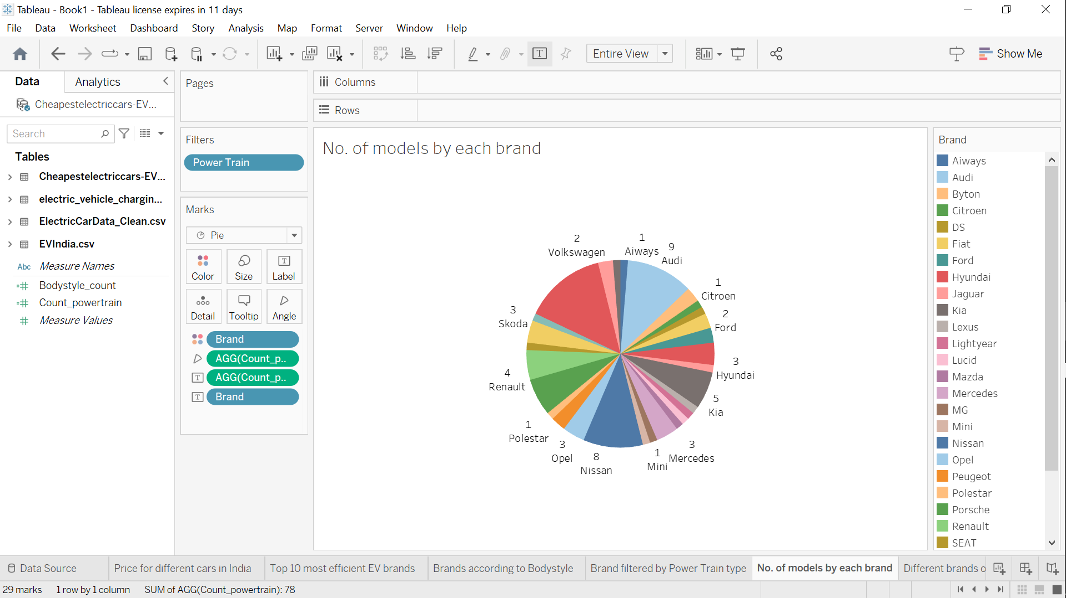





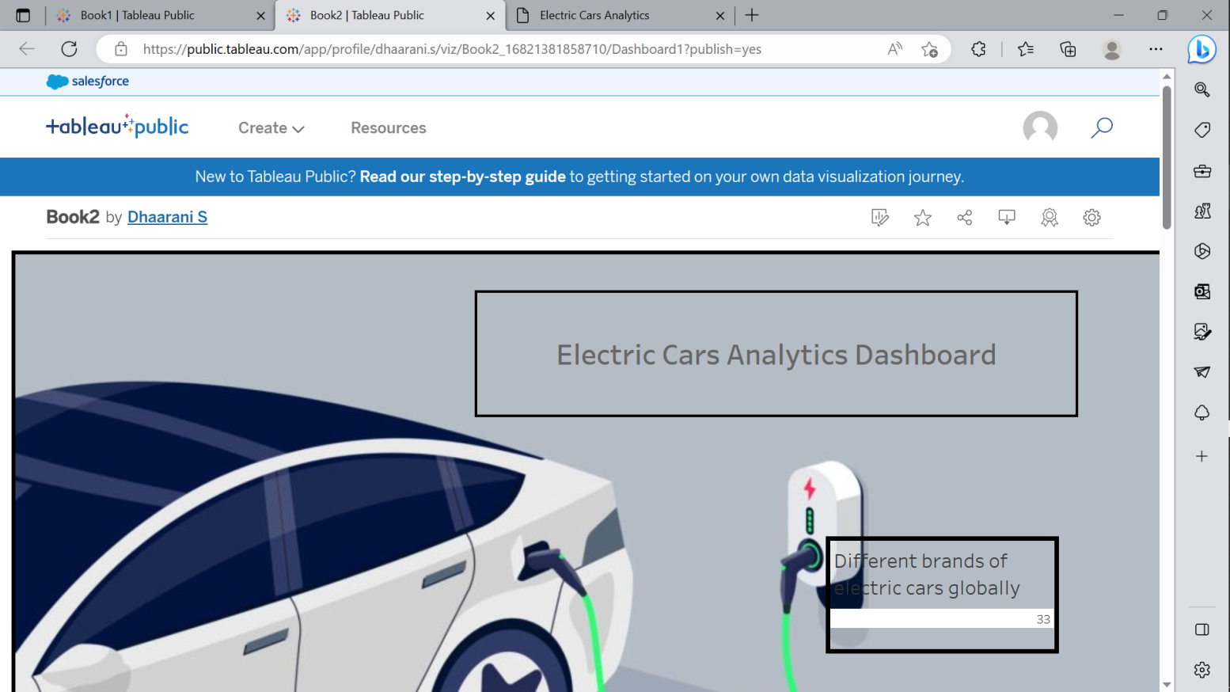

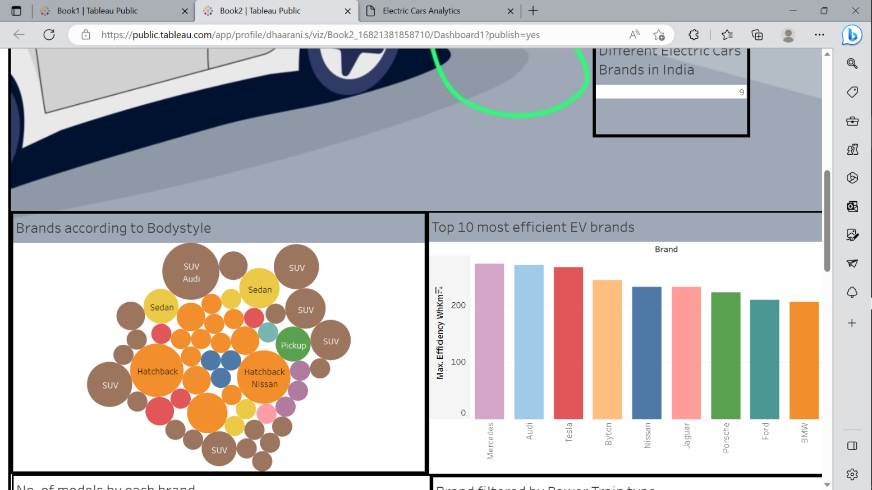

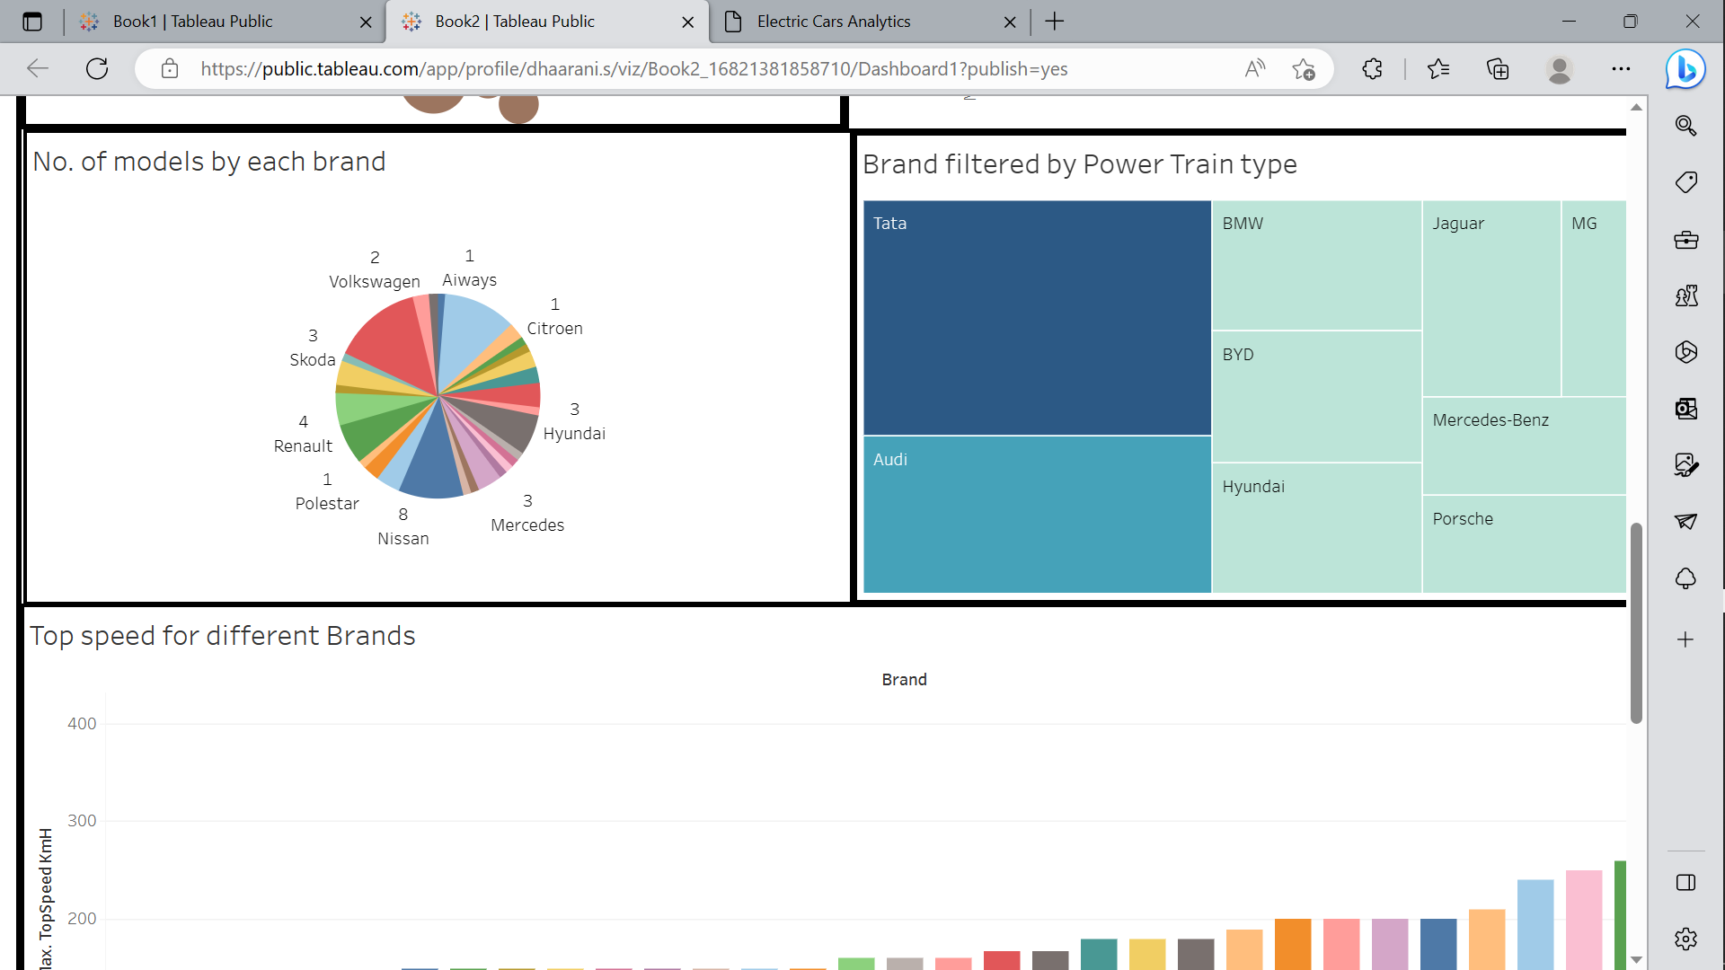

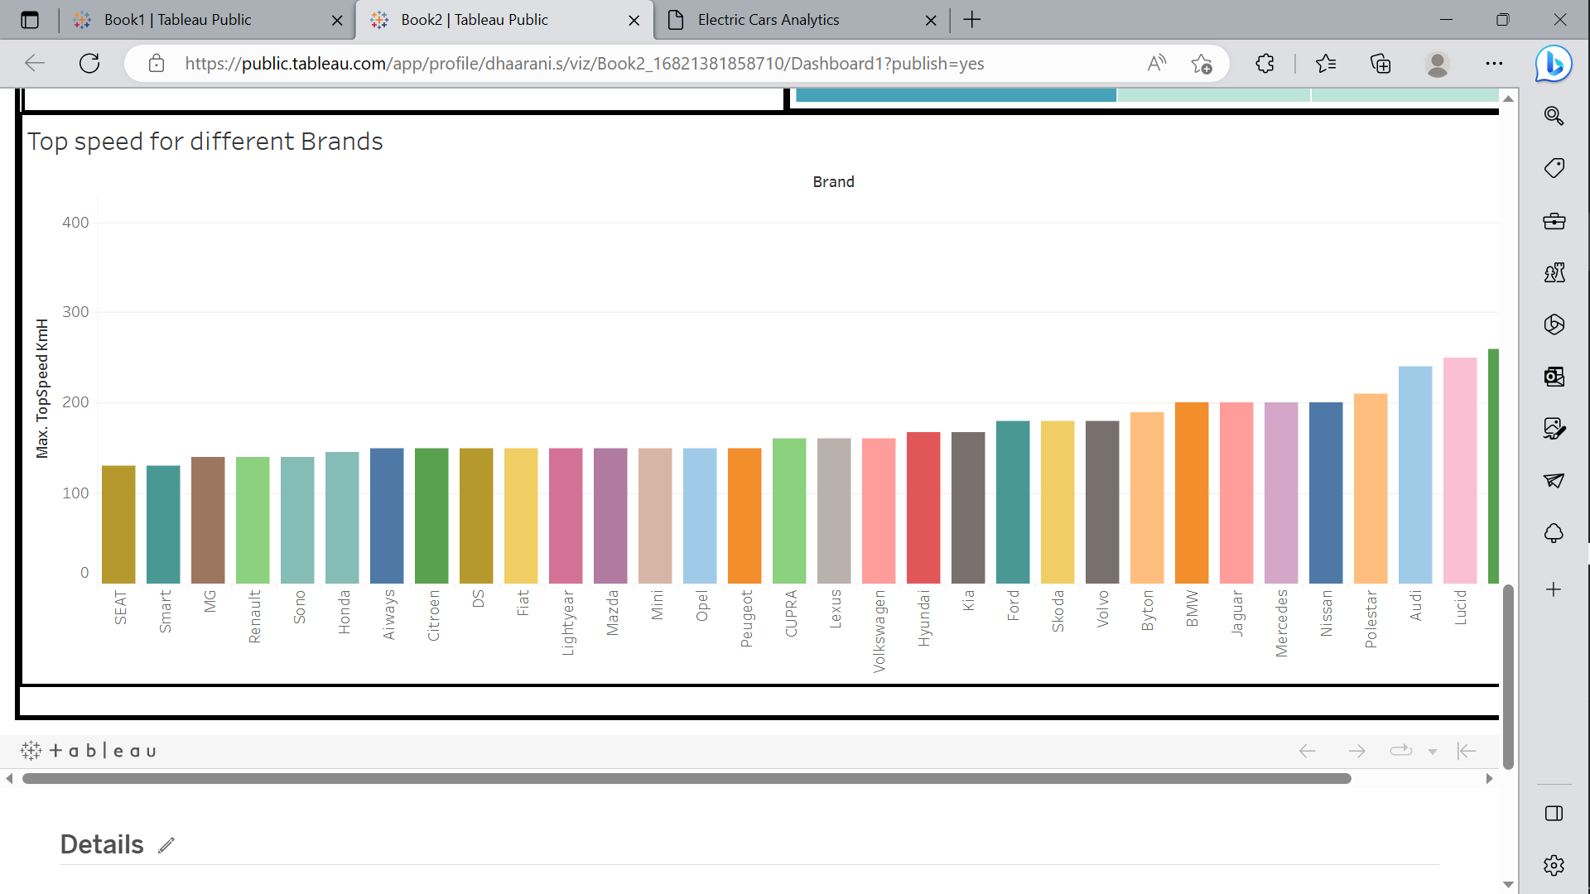

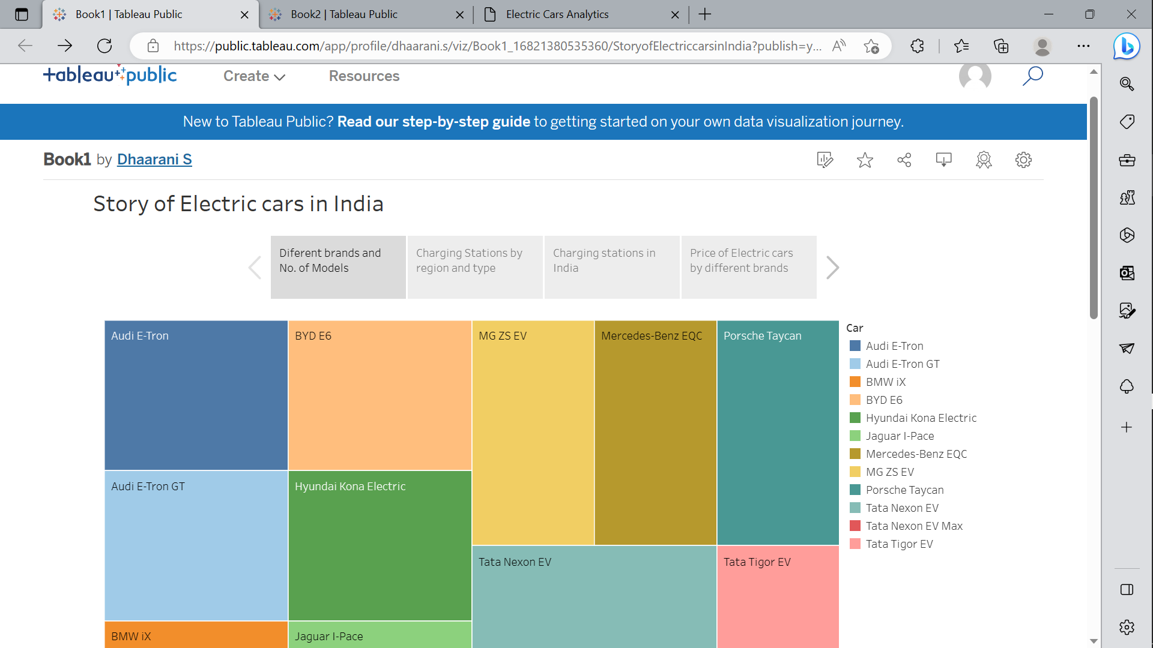

4 Trailhead Profile Public URL

Team Lead - <https://trailblazer.me/id/dhaaranis>

Team Member 1- <https://trailblazer.me/id/meena2929>

Team Member 2 - <https://trailblazer.me/id/rohith771>

Team Member 3 - <https://trailblazer.me/id/narmadhar>

5 Advantage

Environmental benefits: EVs produce zero emissions, which can help reduce air pollution and greenhouse gas emissions.

Energy efficiency: EVs are more energy-efficient than ICE vehicles, as they convert up to 60% of the electrical energy from the grid to power the wheels, while ICE vehicles only convert up to 20% of the energy from fuel to power.

Lower operating costs: EVs are cheaper to operate than ICE vehicles, as they require less maintenance and have lower fuel costs.

Quiet operation: EVs operate quietly, which can help reduce noise pollution.

Instant torque: EVs have instant torque, which means they can accelerate quickly and smoothly.

Incentives: Many countries offer incentives to encourage the adoption of EVs, such as tax credits, rebates, and free charging.

6. Disadvantage

Limited driving range: Most EVs have a limited driving range of around 100-300 miles per charge, which can be a disadvantage for long-distance travel.

Charging time: EVs can take several hours to recharge, depending on the charging method and battery size. This can be an inconvenience for drivers who need to recharge on the go.

Infrastructure: The availability of charging stations is still limited, which can make it challenging for EV drivers to find a charging station when needed.

Battery cost and lifespan: The initial cost of EVs is often higher than ICE vehicles, due in part to the cost of batteries. The lifespan of batteries is also a concern, as they may need to be replaced after a few years.

Weight: EVs are typically heavier than ICE vehicles, due to the weight of the battery pack, which can affect handling and performance.

Cold weather performance: Cold weather can reduce the range of EVs, as batteries are less efficient in low temperatures.

Top of Form

Bottom of Form

1. Future Scope

The future scope for electric vehicle (EV) range and charge analysis is vast, with many opportunities for advancements in technology and data analysis. Here are some potential areas of future development:

Battery technology: Improving the energy density and lifespan of EV batteries can significantly increase the range of EVs and reduce charging times. This could be achieved through the development of new materials or the optimization of existing battery chemistries.

Artificial intelligence (AI) and machine learning: AI and machine learning algorithms can analyze data from EVs to optimize their performance and predict battery health. This could lead to more efficient charging strategies, reduced battery degradation, and better energy management.

Vehicle-to-grid (V2G) technology: V2G technology allows EVs to store and discharge energy back into the grid. This could enable EVs to be used as a distributed energy resource, providing energy to the grid during peak demand periods and reducing the need for additional power plants.

Wireless charging: Wireless charging technology eliminates the need for physical connections between the charging station and the EV. This could make charging more convenient and increase the availability of charging infrastructure.

Advanced data analytics: Advanced data analytics techniques can provide insights into EV usage patterns, charging behavior, and battery performance. This information can help utilities and policymakers plan for future EV adoption and optimize energy management.

Standardization of charging infrastructure: Standardization of charging infrastructure can improve interoperability and increase the availability of charging stations. This could reduce range anxiety and increase the adoption of EVs.

8 The conclusion

In conclusion, electric vehicle range and charge analysis play a crucial role in the adoption and optimization of electric vehicles. By analyzing the range and charge of an EV, drivers can plan their trips, optimize their routes, and manage their battery performance. Fleet managers can also use this analysis to optimize their EV usage and productivity. Energy providers and utilities can use this analysis to plan for the increased demand for electricity and develop new energy storage solutions.

However, electric vehicle range and charge analysis also highlight the current limitations of EVs, such as limited driving range, charging time, and infrastructure. Addressing these limitations through advancements in battery technology, charging infrastructure, and government incentives can help increase the adoption and acceptance of EVs.

Overall, electric vehicle range and charge analysis is a critical tool for EV drivers, fleet managers, energy providers, and policymakers to optimize the performance of electric vehicles and transition to a more sustainable future.